



**CS4051NI/CC4059NI Fundamentals of Computing**

**70% Individual Coursework**

**Milestone 2**

**2024/25 Spring**

**Student Name: Aditya Raj Bohora**

**London Met ID: 24046345**

**College ID: NP01NT4A240056**

**Assignment Due Date: 4th May**

**Assignment Submission Date: 4th May**

**Word Count: 542**

**Project File Links:**

|  |  |
| --- | --- |
| **Onedrive Drive Link:** | Keep Google Drive URL of your Project Here with Anyone in Organization can View Option Enabled |

*I confirm that I understand my coursework needs to be submitted online via MySecondTeacher under the relevant module page before the deadline in order for my assignment to be accepted and marked. I am fully aware that late submissions will be treated as non-submission and a marks of zero will be awarded.*

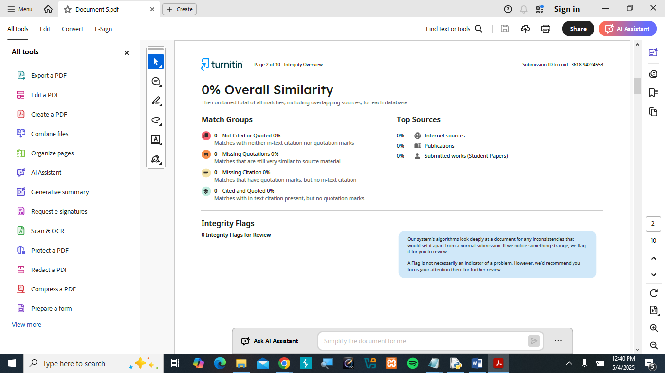

Contents

1) Introduction 4

1.1) Aims and objective 4

1.2) Technologies used while doing coursework 4

**2) Data Structure** 5

**3) Algorithm** 5

3.1) Main program 5

3.2) Buy Products Algorithm 6

3.3) Restock products Algorithm 6

**4) Flowchart** 7

Screenshot of the program 10

Table of Figures

Figure 1 Flowchart of the main program 7

Figure 2 Flowchart of Buy products 8

Figure 3 Flowchart of Restock products 9

Figure 4 Screenshot of the program 10

Figure 5 Output of View Products 11

Figure 6 Output of Buy products 12

Figure 7 Output of Restock products 13

# **1) Introduction**

The objective of this coursework is to develop a proper skin care product sale system by programming in python and we’ll also be describing the program. In this coursework we’ll be including many things like algorithm, data structure and the program itself. All this will be done to create a proper and well-functioning skin care sale system. This report has its own aims and objective and the technologies used which will be discussed below.

## 1.1) Aims and objective

1. To create a simple system that helps manage its product stock and sales. By this system it will be comparatively easier to manage and handle all the product and the stocks including the sales too.
2. One of the main aim and objective is also to show all of the available products in the shop and their selling price. The shops collection of new or existing products to be showcased and the price to be visible to everyone.
3. To reduce the number of stocks of the products after each sale will also be the aims and objective is this report. It is equally important to reduce the number of stocks after each sale to make it organized.
4. To keep everything saved in simple txt files for easy use. By doing this things gets simpler organized and easily accessible.

## 1.2) Technologies used while doing coursework

1. Python: Python is the main programming language which is used to build the system.
2. Text files: This is where all of the product details and invoices are stored.
3. Functions and loops: Functions and loops are used to make code look clean and is used to repeat task easily.
4. Command Line Interface: The program runs in a terminal where there is no need for a fancy app.

# **2) Data Structure**

In Python, data structures are simple tools that help you store and organize information in diffrent ways. A **list** is like a shelf where you can keep things in order and update them whenever you want. A **tuple** is similar to a list, but once you put items in it, you can’t change them, it’s fixed. A **set** is like a box that doesn’t allow duplicates; if you try to put the same thing in twice, it’ll only keep one. A **dictionary** is a bit like a contact list on your phone, you search by a name (the key), and it shows you the number or info (the value). Using these structures makes your programs cleaner, faster, and easier to understand.

# **3) Algorithm**

## 3.1) Main program

Step 1- Start the program

Step 2- Load all the product data from the products.txt file into a list.

Step 3- Display the following main menu with the following four choices View products, Buy products, Restock products and Exit.

Step 4- If the user is to select “**View Products**” it’ll display a table of all the available products in the store with some details like its name, brand, price, quantity and country.

Step 5- Similarly, if the user is to select “**Buy products**” it asks for the customer’s name and also shows the product list.

Step 6- If the user selects “**Restock Products**”, the system will again ask for supplier’s name. It will also go through each product and ask for the quantity.

Step 7- Now if the user chooses to “**Exit**” the system thanks the user and closes the program.

Step 8- End the program.

## 3.2) Buy Products Algorithm

Step 1- Start the purchasing or buying process.

Step 2- Asks the customer to enter their name. This is also important to create a proper invoice of the product they buy.

Step 3- Similarly, the system will then ask the customer to enter the product that they are looking forward to buy.

Step 4- After the customer enters their name and the product they want the system will then ask the customer to enter the quantity they want.

Step 5- Updates the stock and also calculates the total amount that will be charged to the customer.

Step 6- This process generates and saves a sale invoice with the details like date and time. The invoice is automatically generated.

Step 7- 0 to finish, if the user enters 0 to finish it ends the buying session or process.

Step 8 – End the process.

## 3.3) Restock products Algorithm

Step 1- Starts the restock products process.

Step 2- Asks the supplier or vendor’s name to be input into the system.

Step 3- Similarly asks the user to enter the quantity to add for every product accordingly. Also 0 to skip the particular product that comes up.

Step 4- It finally the updates the stock of product that was managed by the user.

Step 5- After all of these process the restock invoice is generated automatically similarly like the buy product invoice.

Step 6- Completion of these process will make the system take you to the main menu once again.

Step 7- Ends the restock process.

# **4) Flowchart**

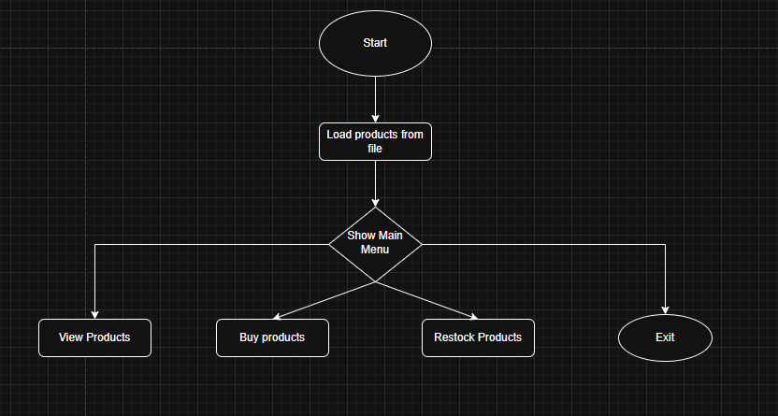

Figure 1 Flowchart of the main program

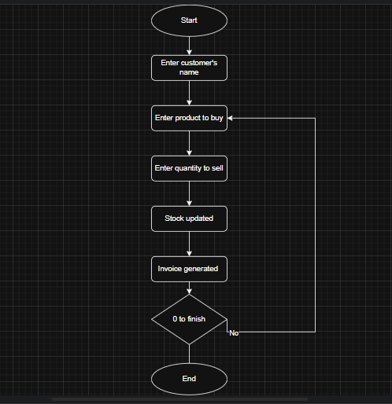

Figure 2 Flowchart of Buy products

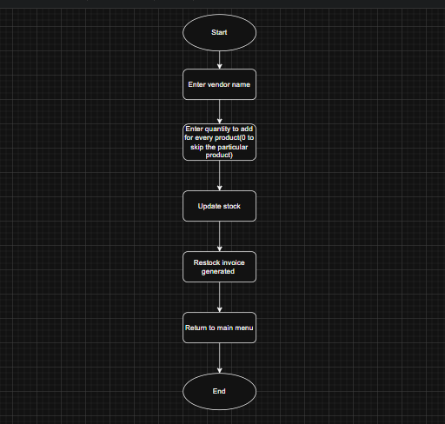

Figure 3 Flowchart of Restock products

# Screenshot of the program

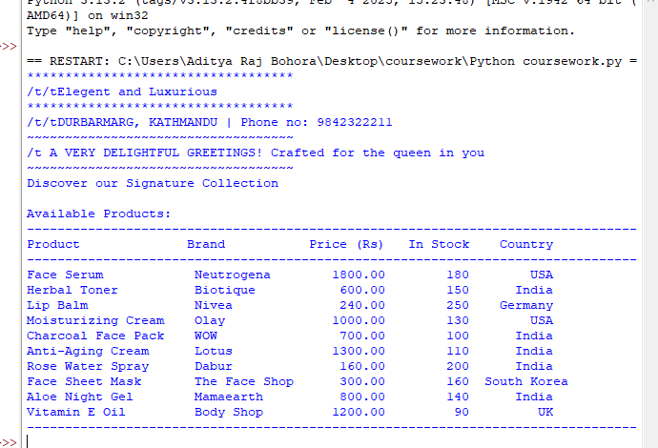

Figure 4 Screenshot of the program

Output of the program

Output of View Products

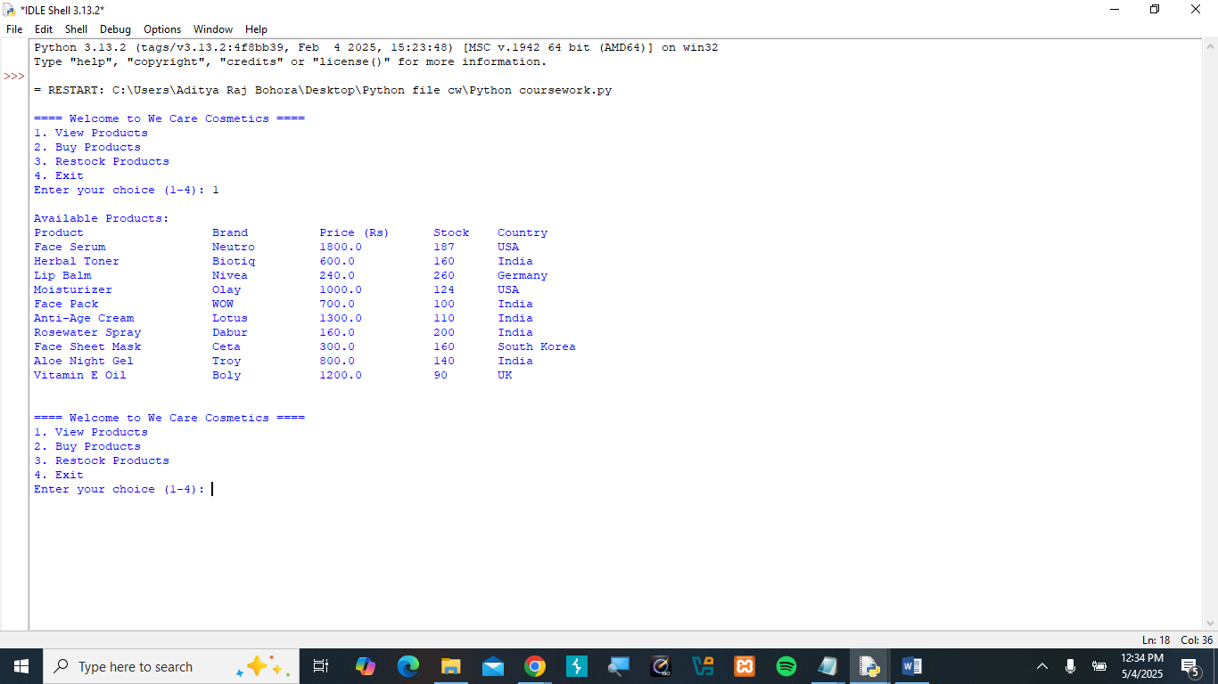

Figure 5 Output of View Products

Output of Buy Products

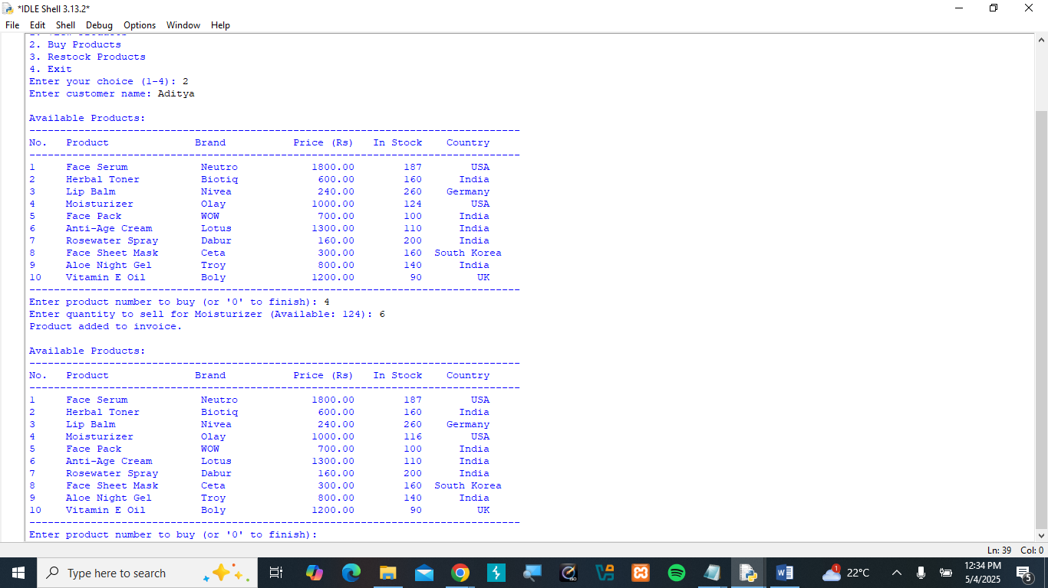

Figure 6 Output of Buy products

Output of Restock products

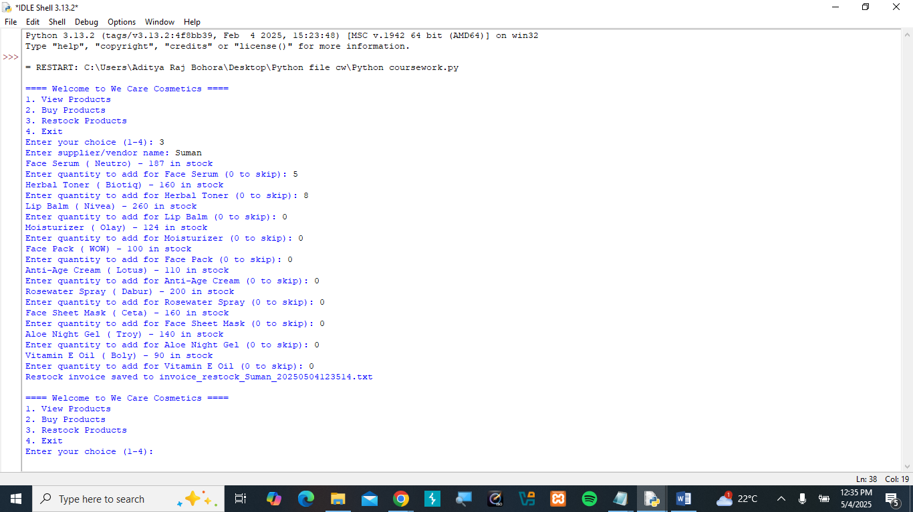

Figure 7 Output of Restock products